Dont Wait Too Long Madeleine Peyroux
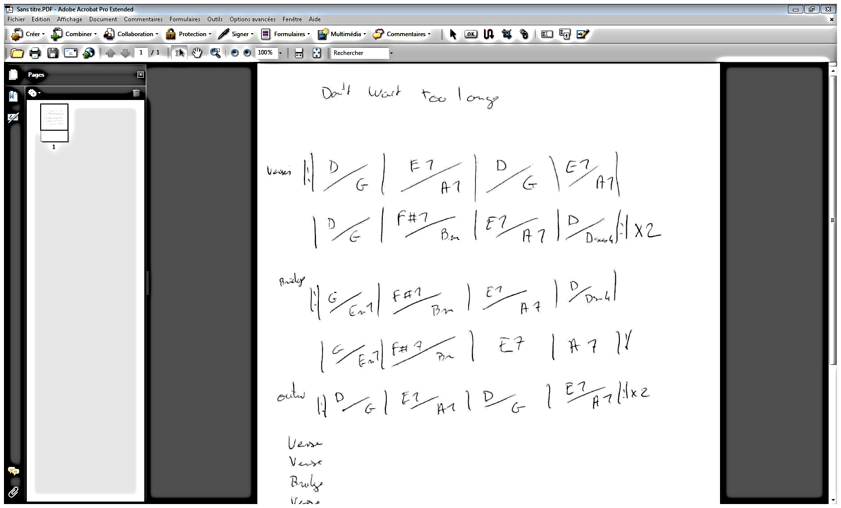
You can cry a million tears
You can wait a million years
If you think that time will change
your ways don't wait too long

When your morning turns to night
Who'll be lovin you by candlelight

If you think that time will change
your ways don't wait too long

Maybe I've got a lot to learn
Time can slip away
Sometimes you gotta lose it all
before you find your way

Take a chance and play your part
Make romance it might break your heart
But if you think that time will change your ways
don't wait too long

Guitar solo

It may rain,
it may shine
Love may age like fine red wine
But if you think that time will change your ways
don't wait too long

Maybe you and I've got a lot to learn
Don't wanna waste another day
Maybe you gotta lose it all
before you find your way

Take a chance and play your part
Make romance it might break your heart
But if you think that time will change your ways
don't wait too long

Don't wait MMmmmmmmmm don't wait

